**How to Install NodeJS in Windows**

1. Visit the link : <https://nodejs.org/en/>  
   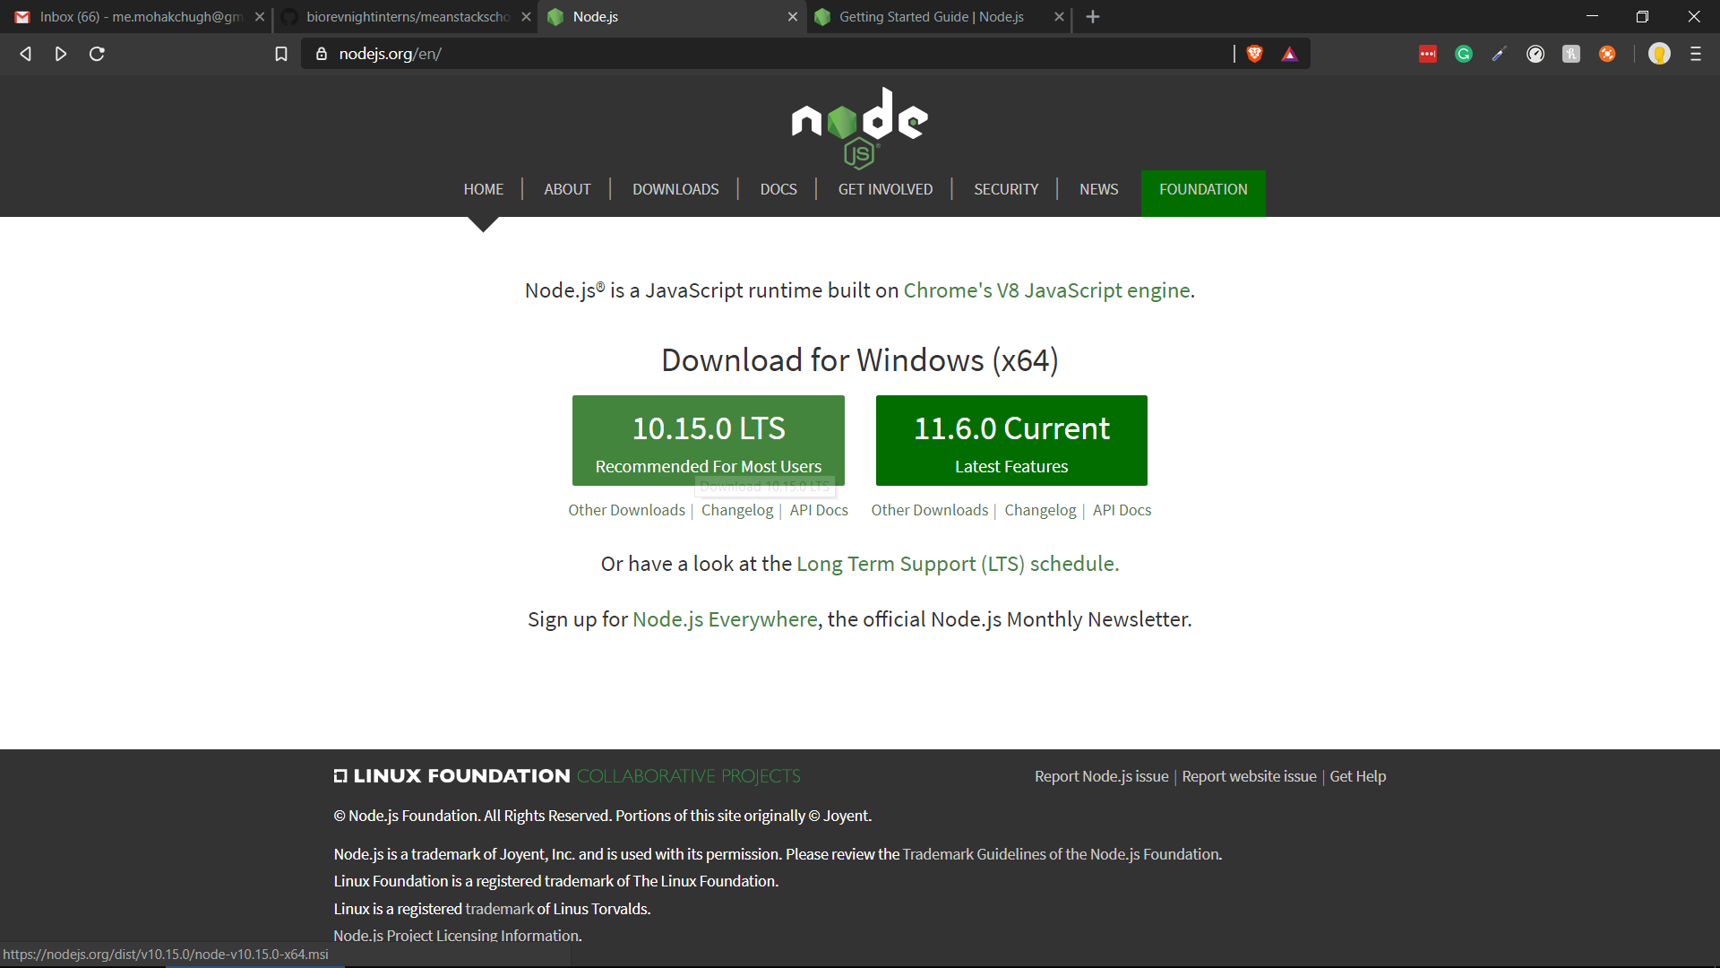
2. Download the LTS version of NODEJSRun the .exe file for installation of NodeJS  
   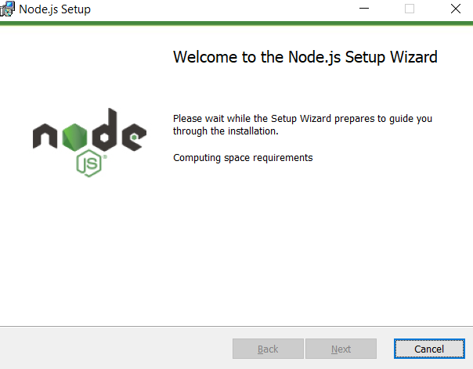
3. Run the wizard
4. Click on agree and run the setup (click next for all the default options – nothing has to be changed)
5. Finish the setup.
6. Check version in cmd by using : node --version  
   